Masterpieces

Ltd

|  |
| --- |
|  |
| Painting Hair System  For beauty centers |
| |  |  |  | | --- | --- | --- | | Second Year | 12/23/17 | Information system | |

**Team’s Names**

* **Doaa Khalid EL-Sayed**
* **Eman Ahmed Abd EL-Tawab**
* **Khalid Mustafa Hussien**
* **Khalid Nabil Hassan**
* **Reham Raafat Shokry**
* **Rekah Mohamed Abd El-Fatah**

**Table of Contents**

**Section 1**

Abstract**3**

Introduction**4**

References**5**

Objectives**6**

**Section 2**

Related Work**7**

Time Plan**8**

System Analysis**19**

**Section 3**

System design **27**

**Section 4**

Implementation**35**

**Abstract**

This is a project introduces system management to painting hair, that system make the work in painting hair or beauty center is more flexible and easy to use, this system abounds many serves to customers like abound the color of painting which customer prefer, make for each painting type artist relative for it and so on.

**Introduction**

This system is a management system for painting hair foundation in which various sections of the administration:

* *Special section of the two colors*
* *Special section for the manager and staff*
* *Customer section*

Each department contains information related to its owner. For example, the staff department contains tools that assist the employee in editing and preserving the data of all employees and clients. In the manager section, tools assist the manager in the administration and in the customer department. Each section is concerned with their data from name, date of attendance and date of arrival to the organization and color Chosen by its designer. System reduced paper based deals and makes managing of foundation be easier than it was before.

Our system save data in a database system implemented and linked by the UI which user acts with.

**Problem Definition**

As we all know that the paper system founded on the basis of several institutions resulted in many mistakes, loss of data and inaccuracy in calculation, conservation and results. So, world turns to the digital system and technology in solving this problem and minimize possible errors.

**Objectives**

1. To Give the Customer the Real Rest.
2. I Can Erase Most of Paper Using’s disadvantages.
3. Our system makes management fast and easily.
4. Our system Gets the Requirements of Customers Easily.
5. Our system is Accurate at Accounts.
6. Our system is accurate in saving data’s customers.
7. Our system reduces losing data’s customers.
8. The Customer Can Choose Requirements in the internet.
9. The Customer Can See Our Works on The Internet.
10. Our System is the structure around which the other parts of our works are framed
11. We Implement This System to Get Our Project successful.

**Related Works**

|  |  |  |  |  |  |
| --- | --- | --- | --- | --- | --- |
| System requirements | Behind  The  chair | Neville Hair & Beauty | Hair ware Beauty war | Neroli Salon | Masterpieces Ltd |
| Booking online |  | **Yes** | **Yes** | **Yes** | **Yes** |
| Price available |  | **Yes** |  | **Yes** | **Yes** |
| News for Hair |  | **Yes** |  | **Yes** | **Yes** |
| Press of Hair business |  | **Yes** |  |  | **Yes** |
| Style hair category | **Yes** | **Yes** |  | **Yes** | **Yes** |
| There is an account for each one | **Yes** |  |  |  | **Yes** |
| It’s easy to use | **Yes** |  | **Yes** | **Yes** | **Yes** |
| Organized | **Yes** |  |  |  | **Yes** |
| Its design isn’t good | **Yes** |  |  |  | **Yes** |
| There are lots of ads | **Yes** |  |  | **Yes** | **Yes** |
| It almost be fast |  |  | **Yes** |  | **Yes** |
| Provides Appointment book |  |  | **Yes** |  | **Yes** |
| Has stock management |  |  | **Yes** | **Yes** | **Yes** |

**Time Plan**

|  |  |  |  |
| --- | --- | --- | --- |
| TASK Nu | **Description** | **Duration** | **Dependent or Not** |
| 1-determinte system actors | Determine who will use the system (individual / organization /anther actor) | Just 2/10/2017 | Not Dependent |
| 2-interviwe with system actors | I’m a developer so it’s  Necessary to know who will use the system and interviews with him | 8 days | Dependent on task 1 |
| 3- collect system requirements | in this phase collect what task it is  this phase will be meeting and make an interview to know:  1-who will use our system  2- when client need the system  3 - system for client or organization | 8 days | Dependent on task 2 |
| 4-analysis system requirements | In System Requirements Analysis Designers Should Determine  User Requirements and Determine Effective Tools to Deal With  . After Divide Requirements into Parts and Determine  Easiest and hardest part  Into System To make it usability to system users. | 8 days | Dependent on task 3 |
| 5-disgn the plan | Concept of design a plan relates to creating steps and rules we work on it for achieve a main output.  The next step after analyzing system is to design the plan which we will work according it during the developing of the system.  Design a plan depends on analyzing system’s requirements (budget – resources – needs of the user), so design a plan is important for divide developing the system into tasks with a time plan.  Design a plan include:   * Problem framing and developing * Research * Analysis of research   Prototyping and testing | 8 days | Dependent on task 4 |
| 6- time plan | Time plan depends on our plan we designed before, which means it’s very important to make a time plan during developing, we should make a timeline and deadline of every task we put in the plan, we should put a mine stone describe what tasks have we finished and what we haven’t finished yet. | 3 Days | Dependent on task 5 |
| 7 - estimate system cost | Determine the system requirement’s budget and cost | 4 Days | Dependent on task 4 |
| 8- design uml diagram | What is a UML Diagram?  UML is a way of visualizing a software program using a collection of diagrams.  The notation has evolved from the work of Grady Booch,  James Rumbaugh, Ivar Jacobson, and the Rational Software Corporation to be used for object-oriented design,  But it has since been extended to cover a wider variety of software engineering projects.  Today, UML is accepted by the Object Management Group (OMG) as the standard for modeling software development  it not contains forgin key | 5days | Dependent on task 4 |
| 9 - design data base | design data base after analysis system requirements and collect system requirements  in design database draw all tables, attributes and values set primary key and forgin key in tables | 5 days | Dependent on task 8 |
| 10- design forms records | Design the Performance, reports and interface…...  With fouce on usability | 4 days | Dependent on task 9 |
| 11-implement system | In Implementing System designers think how to get best results  After do some Operations Depending On requirements. Briefly  Get Effective output from simple input. | 10 days | Dependent on task 5 |
| 12- maintain final system | in this task should maintain all data and our system to be ready to use by client | 5 days | Dependent on task 11 |
| 13- testing the delivered system | In this task  Tests if system is valid or not | 6 Days | Dependent on task 12 |

**Activity Network**

In which the initial time plan in diagram describe when is our early start, early finish, last start, last finish and the critical path of our project.

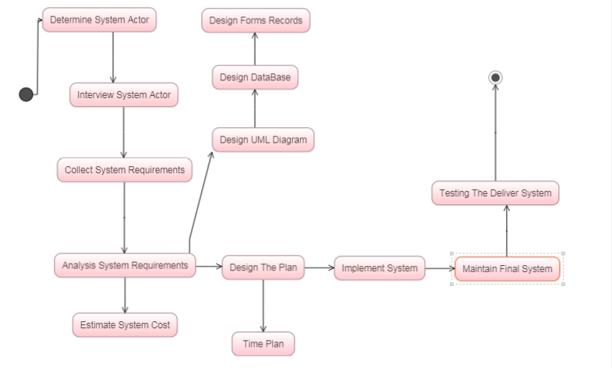

**Gantt Chart**

In which an automated chart created after calculations of

time in the Activity Network.

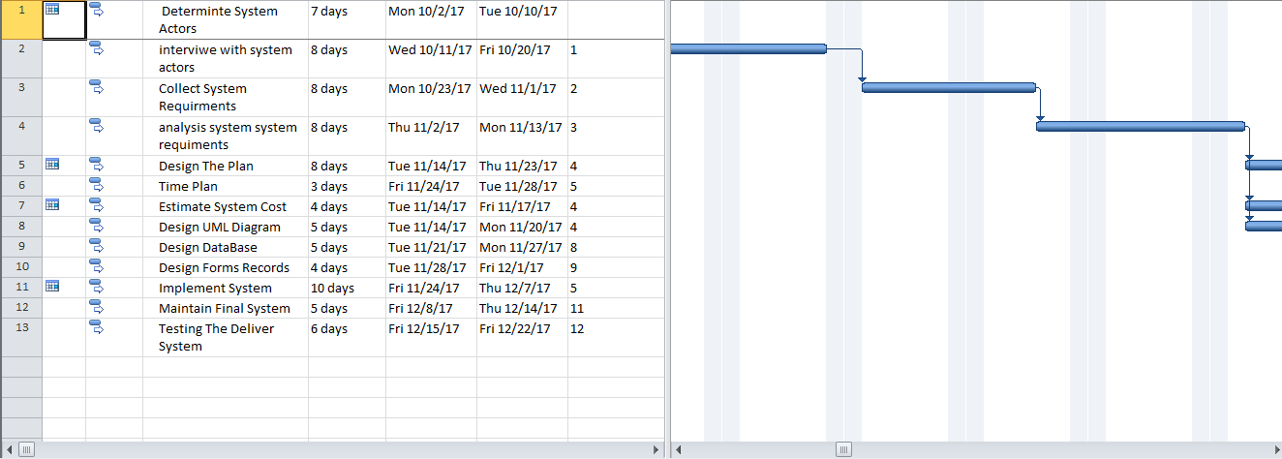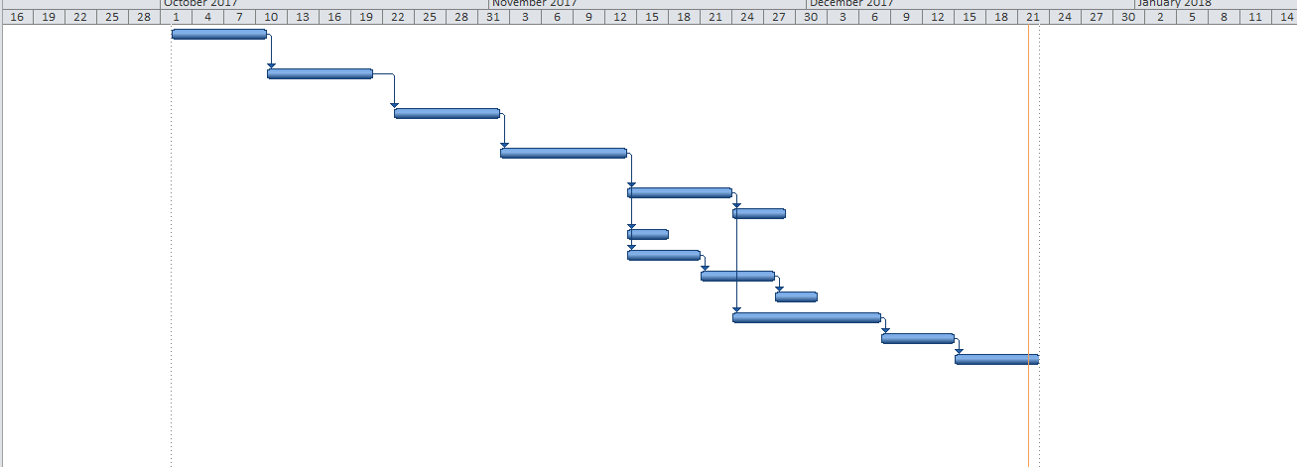

**System Analysis**

* **System Requirement**
* **User Requirement**
* **Functional Requirement**
* **Non-Functional Requirement**

**User Requirement:**

1. Our software provide admin to search about client’s information.
2. The system must be able to manage the details of customers.
3. The system abounds that each painting can only have one artist associated with it.
4. Each user can choose specified hair color.
5. the system provides for customer 10% of price’s painting form the owner to painting if the painting not valid.
6. The owner of that customer rental price. Any paintings that are not hired within six months are returned to the owner. However, after three months, an owner may resubmit a returned painting.

**System Requirement:**

* 1. – the admin should log in to the system first
  2. – The admin will show box to write what he wants.
  3. - the admin can search by name or hair color
  4. –this clients is in our database
     1. **–** *If not, the admin will insert client information into system database*
     2. **-** *If already exist in system database the admin will update or delete data or alter data.*
  5. In the end if the client should pay bills the admin will update system account.

**2.1-** The user will tell the receptionist these name

**2.2** **-** If he / she is old user in his / her information we show the last date he/she paint heir.

**2.3-** If Last date less than 3 month he / she can’t paint again before 3 months

**2.4-** If Last date more than 3 month ask about what color he / she want.

**2.5-** Tell the user the names of artist do it and she / he choose one

**2.6-** Artist tell the user which company product the color he / she wand and choose one

**3.1 -**The system categorized the painting as B (bronze), S (silver), G (gold) or P (platinum).

**3.2-** The system categorized his artists as each artist is prefect in which color of painting.

**3.3-** Thereafter each painting can only have one artist associate with it.

**3.4 -**The customer isn't like his painting hair, he can reflux to the artist specialist.

**3.6-** The artist is accountable to repair the painting hair color for the customer.

**3.7**- The artist writes a report of all paintings submitted for hire.

**3.8-** The artist returns report for those paintings not hired over the past six months.

**4.1 –** user should enter name and password.

**4.2 –** the admin will check the data.

**4.2.1 –** *if the data correct he will login.*

**4.2.2 –** *if the data is not correct he won’t login.*

**4.3 –** the admin will search if the color is available or not.

**4.3.1 –** *if the color available then the user uses it.*

**4.3.2 –** *if the color is not available then the user should choose another color*.

**5.1-** the customer will choose which company product he wants to paint.

**5.2-** if any paintings are not valid or hired within six months are returned to the owner of this paintings.

**5.3-** the owner of the paintings is then paid 10% of that customer rental price.

**5.4-** after 3 months the owner to this painting resubmit a returned painting.

**6.1-** customers will complain from type of paintings.

**6.2**- we will check first the duration of this type in database.

**6.3**- if it hasn’t completed 6 months’ yet, we will mark this production.

**6.4-** after three months, if this production had more than 1 complication, manager should return it to owner.

**6.5-** we will search about user’s names who complained from paintings and give them 10% cash compensation.

**Functional Requirement:**

* 1. System will compare the name of client if exist or not.
  2. - manage the details of customers, paintings and those paintings currently on hire to customers

**3.1 -** The system categorized the painting and his artists as each artist is prefect in which

Color of painting.

**3.2-** Each painting can only have one artist associate with it.

**4.1 –** check – search – update

**5.1-** The owner of the painting is then paid 10% of that customer rental price for not valid painting and replace it after 3 months

**6.2-** we will check first the duration of this type in database.

**6.5-** we will search about user’s names who complained from paintings and give them 10% cash compensation.

**Non-Functional Requirement:**

* 1. The admin will enter the name of clients.

**2.1-** Customers Take discount of 0%, 5%, 10% or 15% respectively if chose categorized as B (bronze), S (silver), G (gold) or P (platinum).

**3.1 -**The customer can reflux to the artist specialist, if he doesn't like the color Painting hair.

**4.1 –** enter – login – choose – appreciate.

**5.1**- if any paintings are not hired within six months are returned to the owner, and the owner will have paid 10% from the price of the painting to customer.

**6.3**- if it hasn’t completed 6 months’ yet, we will mark this production.

after three months, if this production had more than 1 complication, manager should return it to owner.

**System Designs**

**The design of our database is a lengthy task that can be done through a step-by-step process.**

**ERD Diagram**

A graphic representation that shows entities of our system and relationships between them.

A close up of text on a white background

Description generated with high confidence

**Database Diagram**

Based on ERD Diagram, this is the database

diagram of the system.

A screenshot of a social media post

Description generated with very high confidence

**Schema**

Painting

|  |  |
| --- | --- |
| Painting_ID | Painting_Name |

Company

|  |  |
| --- | --- |
| Com_ID | Com_Name |

Customer

|  |  |  |  |  |  |
| --- | --- | --- | --- | --- | --- |
| Cus_ID | C_F_Name | C_M_Name | C_L_Name | O_Color | N_Color |

Address

|  |  |  |  |
| --- | --- | --- | --- |
| Emp_ID | St_No | St_Name | St_Postion |

Phone(Artist)

|  |  |
| --- | --- |
| Artist_ID | Artist_phone |

Address(Company)

|  |  |  |
| --- | --- | --- |
| Com_ID | St_No | St_Postion |

Phone(Company)

|  |  |  |
| --- | --- | --- |
| Com_ID | Com_Fax | Com_PostCode |

Phone(Customer)

|  |  |
| --- | --- |
| Cus_ID | C_Phone |

Manager

|  |  |  |  |
| --- | --- | --- | --- |
| Emp_ID | Qq11134M_ID | Email | Address |

Artist

|  |  |  |
| --- | --- | --- |
| Emp_ID | Artist_ID | Category |

**GUI**

The Graphical User Interface of the system

Allows the user to interact visually with our system.

When users open the application, he will see the first form in which login field in which the user type name and password.

A picture containing indoor, floor, table, wooden

Description generated with very high confidence

Inside the code of this form, a Validation Code in which a condition prevents the user from entering the program until he writes the correct name and password as implemented inside it.

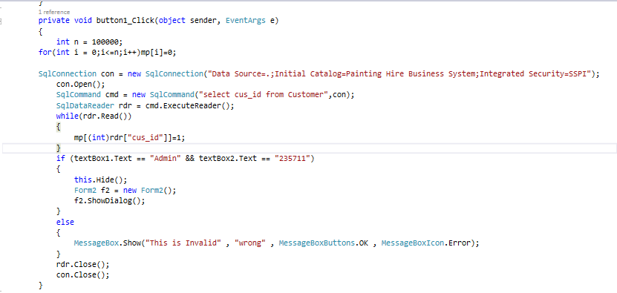

When user inter a valid username and password, show the next form

1. **Form 2**

* In this form user determine and select if he owner or artist
* If he is artist
* Enter ID,
* Select prosses wanted to do such display, display all, insert, update, delete or Exist the application
* Function insert to add data’s customer.
* Function display to display and show all works.
* Function update to update data after any changes as insert or delete data’s customer.

As shown:

A screenshot of a computer screen

Description generated with very high confidence

**3)If user choose artist**

* Open the third form,
* In this form artist can
* add data to customers by using function add,
* search about customer by using function search,
* update in data client by using function update
* back and exist application.

As shown:

A picture containing indoor

Description generated with high confidence

**4)If user choose owner**

* Open the owner form,
* Owner can display all data
* can add data
* update data
* delete data
* or exist the program.

As shown:

A screen shot of a computer

Description generated with high confidence

**Implementation**

**In stored procedure (ad)**

In this stored we add input data into our database in two table Customer and Hire.

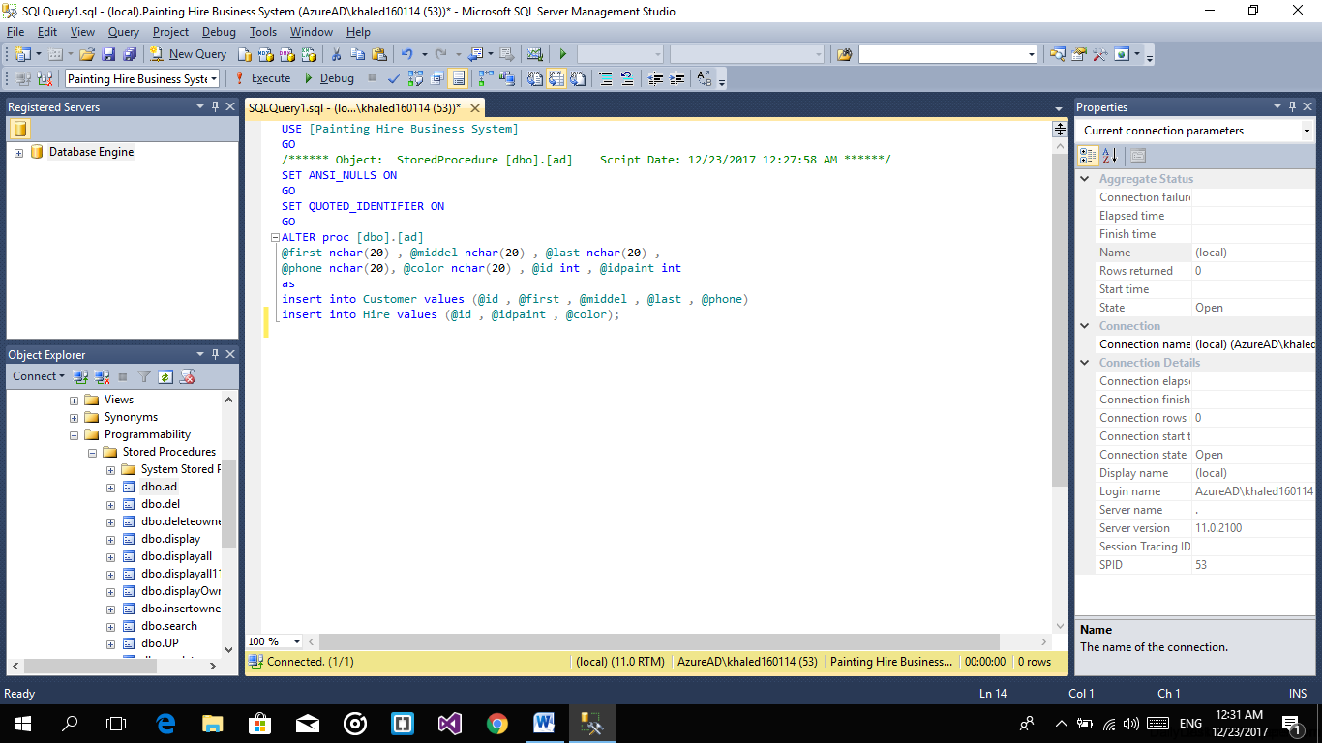

**In stored procedure (del)**

In this stored we Delete specific input user choose and delete all related data in other tables

Here will delete data from customer and Hire tables.

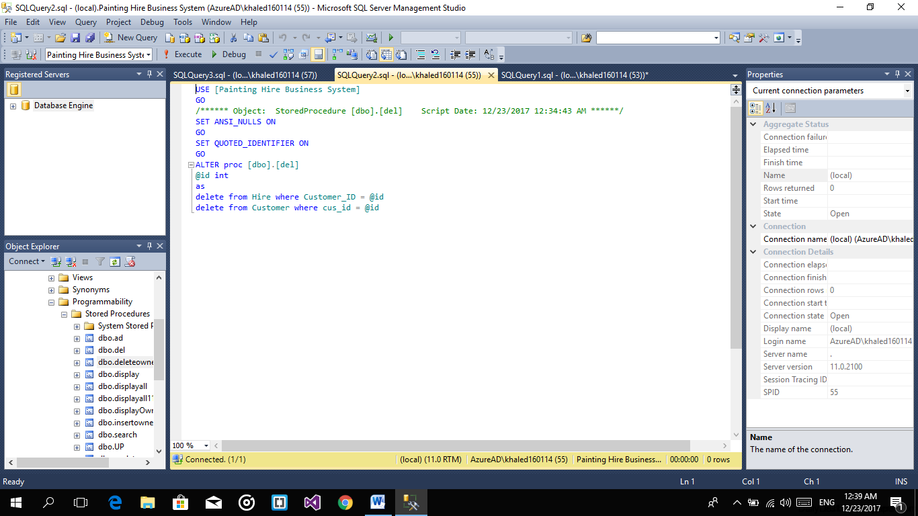

**In stored procedure (delete owner)**

In this stored we Delete specific input user choose and delete all related data in other tables

Here will delete data from owner, painting and hire tables.

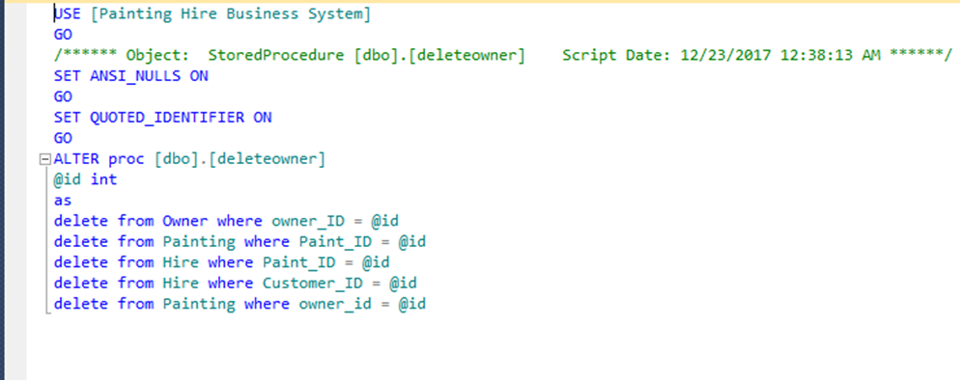

**In stored procedure (display)**

In this stored we will Display specific input data and show all data about it in the grid system

We will display data from customer and painting tables.

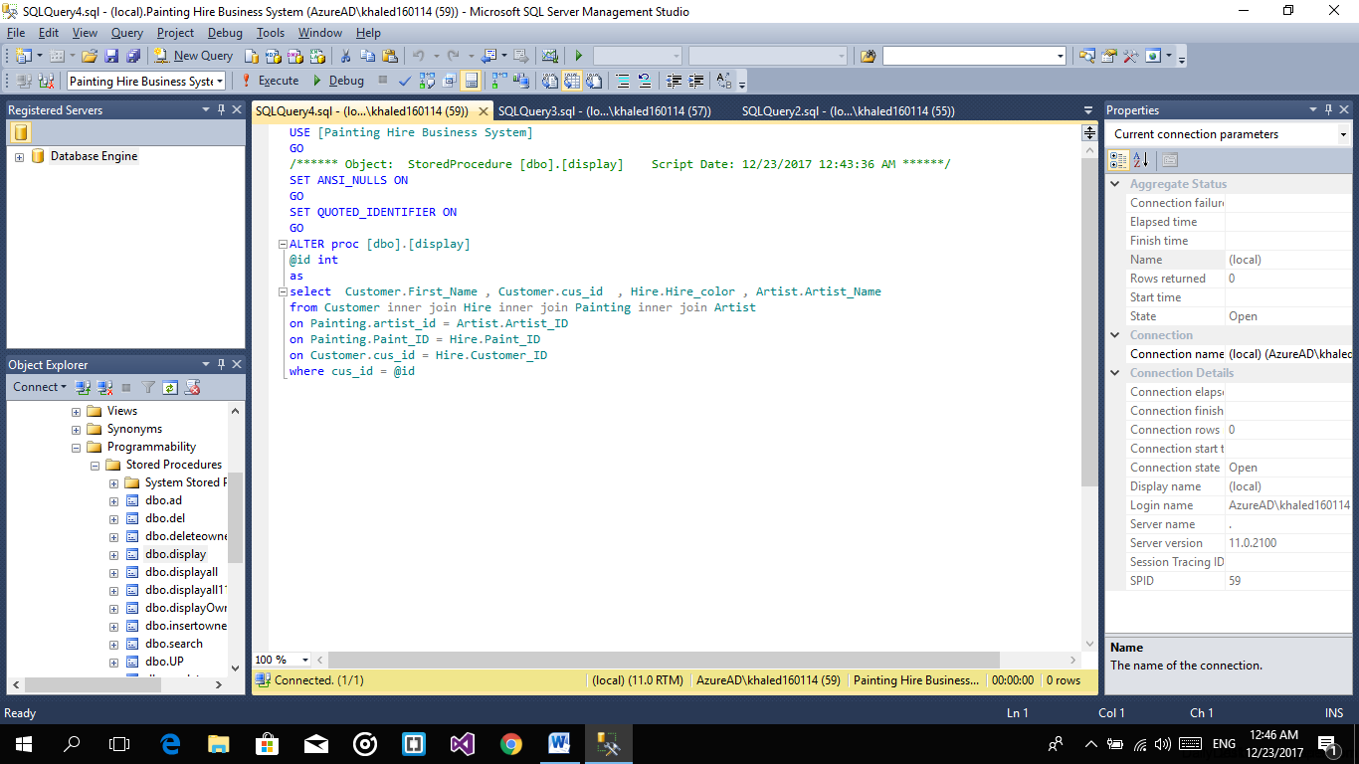

**In stored procedure (display all)**

In this stored we will Display data and show all in database in the grid system

But in this tables only: customer and painting.

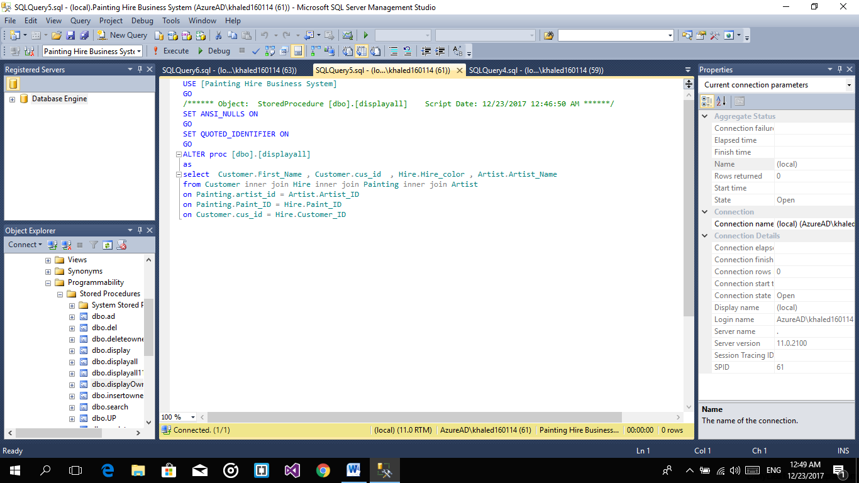

**In stored procedure (display owner)**

In this stored we will Display data about table owner only all data about it.

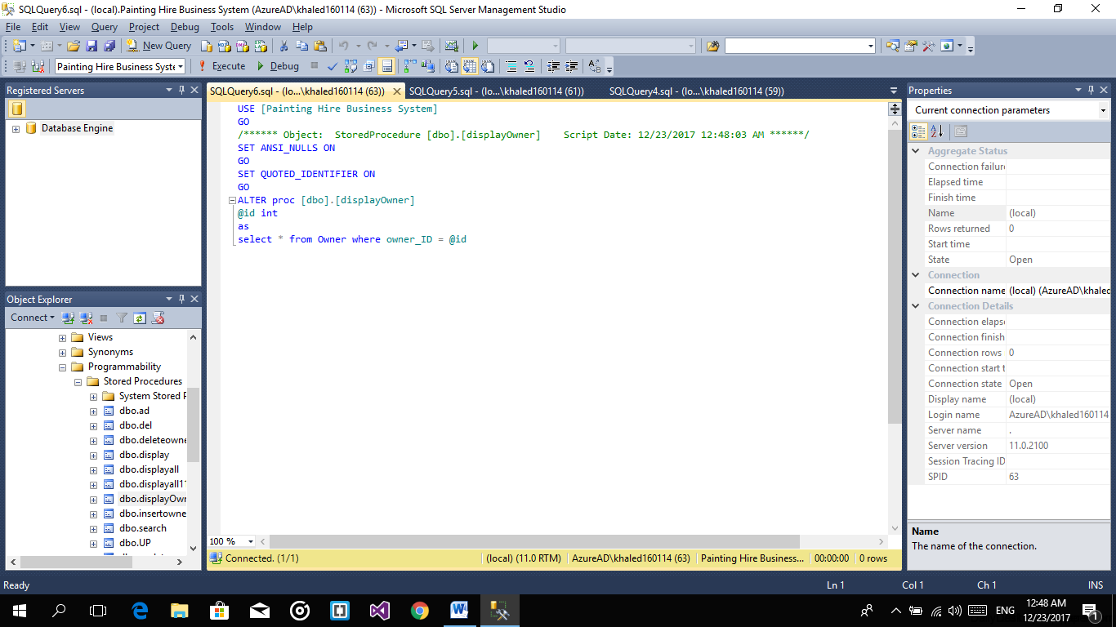

**In stored procedure (insert)**

In this stored we will add a new data in database user will give it in text box

This data belongs to owner table and will put it in this table.

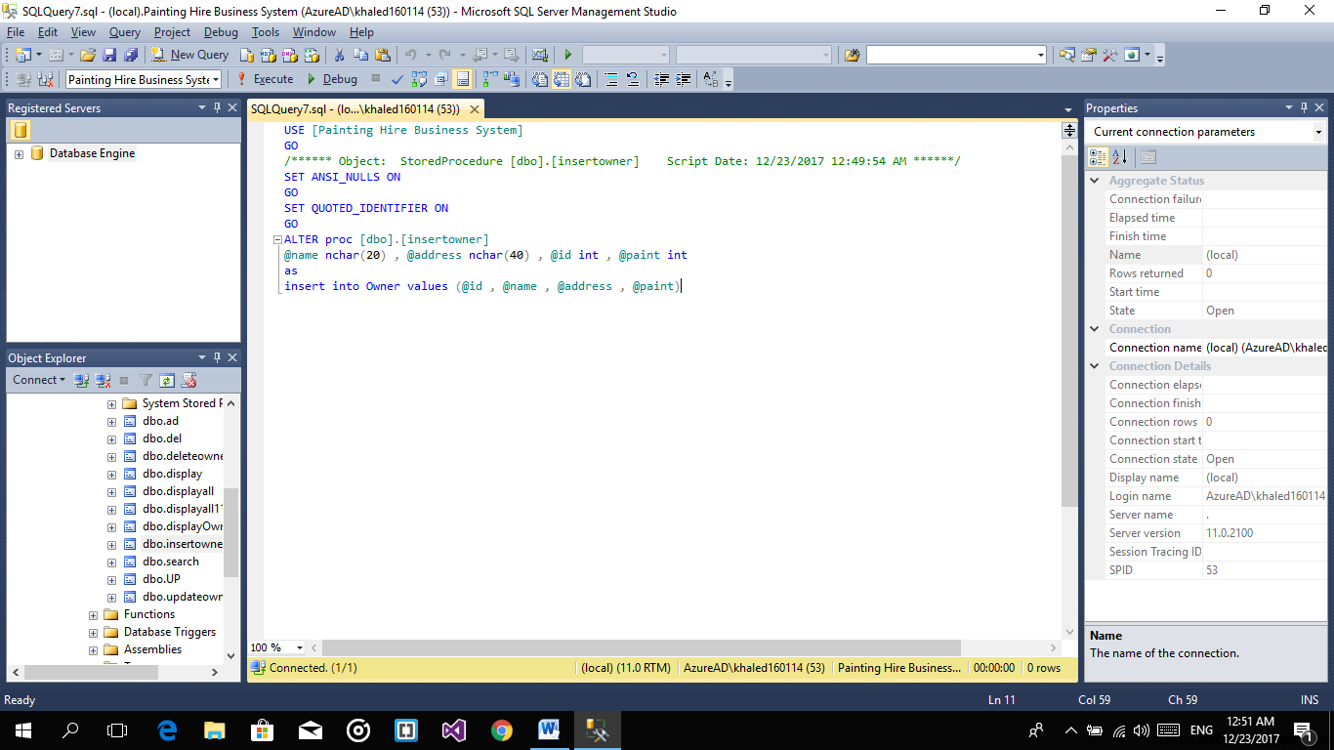

**In stored procedure (search)**

In this stored we will search a specific id and put all data belongs to this id in a specific text box

This operation done in customer and painting tables.

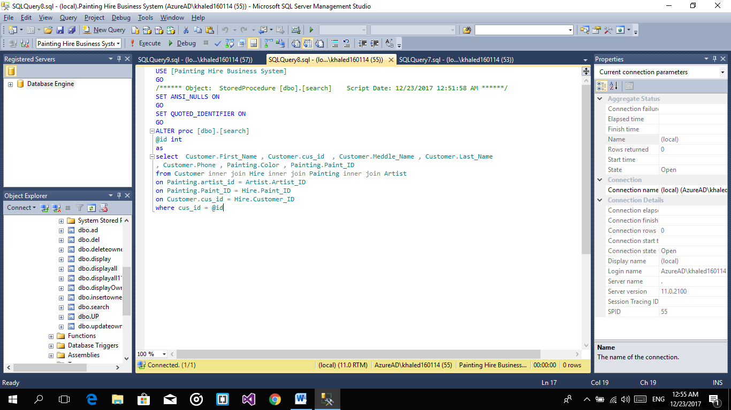

**In stored procedure (up)**

In this stored we will update data which id user chose and update all data in database and save it

This operation done in customer and painting tables.

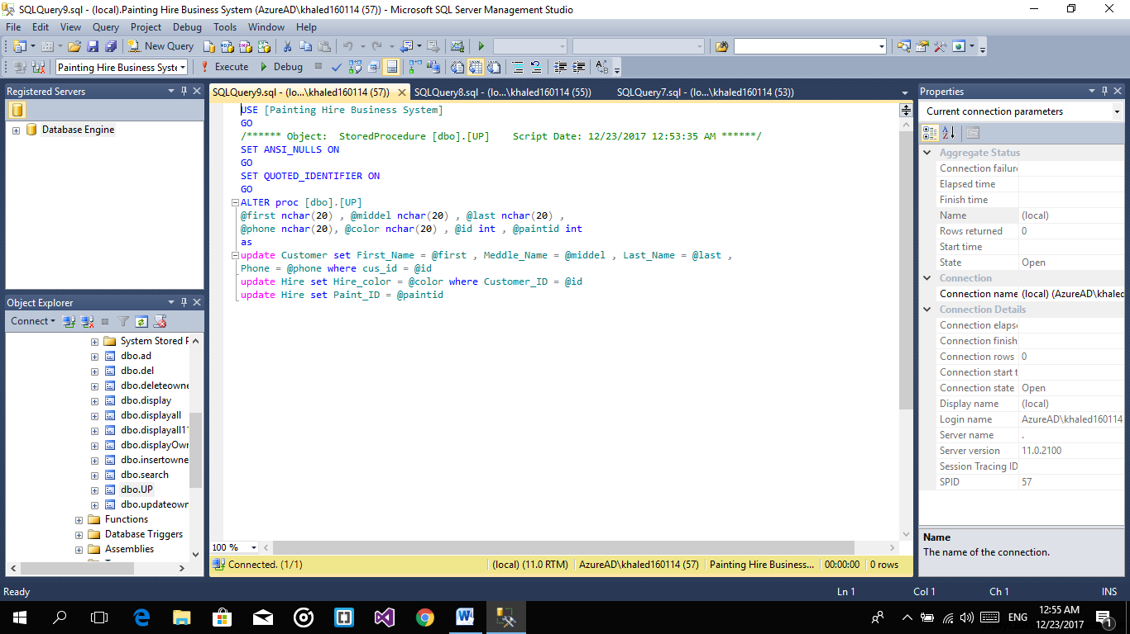

**In stored procedure (update owner)**

In this stored we will update data which id user chose and update all data in database and save it

This operation done in owner table.

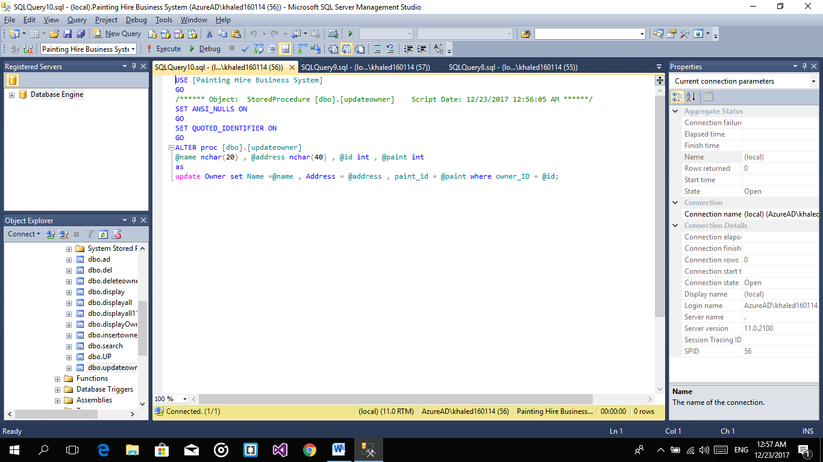

**References**

* Visual Studio 2015 (C#)
* Microsoft SQL Server 2012
* Microsoft Project Management
* https://dashboard.genmymodel.com/